Safeguard Mechanism reform consultation - factsheet 3

January 2023

## **Baseline setting: an illustrative example**

*Emissions limits—or baselines—for individual facilities will be set in a way that enables business growth even as emissions fall, and introduces costs in manageable increments. A decline factor will apply to all baselines to ensure the Safeguard Mechanism delivers a proportional share of Australia’s national climate goals. The government proposes that each facility’s baseline will fall by 4.9% each year to 2030 (see factsheet 2).*

## **Baseline setting: the basics**

Baselines will be set using a production‑adjusted (emissions-intensity) framework. This means baselines will rise and fall with production, helping to decouple emissions and economic growth. In a simplified form, the baseline setting formula is the sum of production multiplied by emissions intensity for all relevant outputs at the facility:

**Facility baseline = Ʃ production x emissions intensity (1)**

for all relevant outputs, where:

* **production** is the quantity of the product or service being delivered, for example tonnes of alumina or passenger kilometres
* **emissions-intensity** is the emissions per unit of production, for example, emissions per tonne of alumina or emissions per passenger kilometre.

## **What emissions-intensity value will be used?**

The emissions-intensity value will combine industry average performance with the performance of each facility. This means baselines will start close to each facility’s actual emissions, but move to an industry average benchmark by 2030. This hybrid approach will ensure costs and benefits are introduced in manageable increments, while encouraging the least emissions-intensive production.

The revised formula is:

**Facility baseline = Ʃ Production [(a × EIIA) + (b × EISS)] (2)**

* **EIIA** is the **industry average emissions intensity** of production, measured as the average of existing industry performance and published in Schedule 2 of the Safeguard Rule.
* **EISS** is the **site-specific emissions intensity** of production, measured as the emissions per unit of output at each particular Safeguard Mechanism facility.
* **a and b** represent the ratio of industry average and site-specific emissions-intensity values (where a + b = 1) outlined in Table 1.

*Table 1: Ratio of emissions-intensity values under the hybrid baseline setting model*

|  |  |  |  |  |  |  |  |
| --- | --- | --- | --- | --- | --- | --- | --- |
|  | 2023-24 | 2024-25 | 2025-26 | 2026-27 | 2027-28 | 2028-29 | 2029-30 |
| Industry average (a) | 0.1 | 0.2 | 0.3 | 0.4 | 0.6 | 0.8 | 1 |
| Site-specific (b) | 0.9 | 0.8 | 0.7 | 0.6 | 0.4 | 0.2 | 0 |

## **Reducing emissions: introducing baseline decline**

Aggregate baselines must fall for the Safeguard Mechanism to contribute to Australia’s climate goals. The government proposes that facility baselines will fall by **4.9% each year to 2030**.

This decline rate is sufficient to ensure that—even with individual facility baselines rising and falling with production—aggregate emissions will fall consistent with the Safeguard Mechanism target. The revised baseline setting formula will be:

**Facility baseline = Ʃ Production [(a × EIIA) + (b × EISS)] × decline factor (3)**

where the **decline factor** reflects the cumulative decline rate, as described in table 2.

*Table 2: Decline factor*

|  |  |  |  |  |  |  |  |
| --- | --- | --- | --- | --- | --- | --- | --- |
|  | 2023-24 | 2024-25 | 2025-26 | 2026-27 | 2027-28 | 2028-29 | 2029-30 |
| Decline factor | 0.951 | 0.902 | 0.853 | 0.804 | 0.755 | 0.706 | 0.657 |

## **Hypothetical example**

Assume there are two facilities in a sector and they produce equal quantities of a particular product:

* **Facility A**: has a site-specific emissions-intensity value of 0.8 tonnes CO2‑e per tonne of product.
* **Facility B**: has a site-specific emissions-intensity value of 1.2 tonnes CO2‑e per tonne of product.
* **Industry average**: Each facility produces 250,000 tonnes of product per year, so the production-weighted, industry‑average emissions-intensity value is 1 tonne CO2‑e per tonne of product.

## *The hybrid model*

Using the hybrid baseline setting approach, the emissions-intensity values for facilities A and B will start close to their current performance and converge to industry average by 2030 (see table 3).

*Table 3: Emissions-intensity values for Facilities A and B using the hybrid model*

|  |  |  |  |  |  |  |  |
| --- | --- | --- | --- | --- | --- | --- | --- |
|  | 2023-24 | 2024-25 | 2025-26 | 2026-27 | 2027-28 | 2028-29 | 2029-30 |
| Facility A | 0.82 | 0.84 | 0.86 | 0.88 | 0.92 | 0.96 | 1.00 |
| Facility B | 1.18 | 1.16 | 1.14 | 1.12 | 1.08 | 1.04 | 1.00 |

Figure 1 shows that the hybrid model introduces the costs and benefits of Safeguard Mechanism reforms in manageable increments. Before the decline factor is applied, the credits generated at facility A matches the exceedance at facility B. Demand for SMCs matches supply, so there is no change in aggregate Safeguard Mechanism emissions.

*Figure 1: Hybrid baselines, before decline factor*

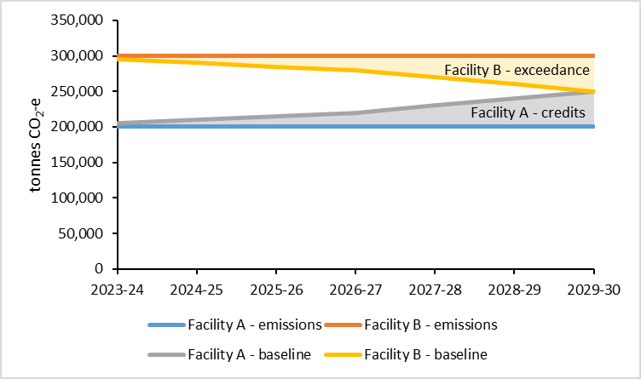

## *Reducing emissions*

The Safeguard Mechanism will reduce emissions by applying a decline factor to individual facility baselines. Figure 2 illustrates how supply and demand for SMCs changes as baselines fall by 4.9% each year.

*Figure 2: Illustrating the impact of baseline decline*

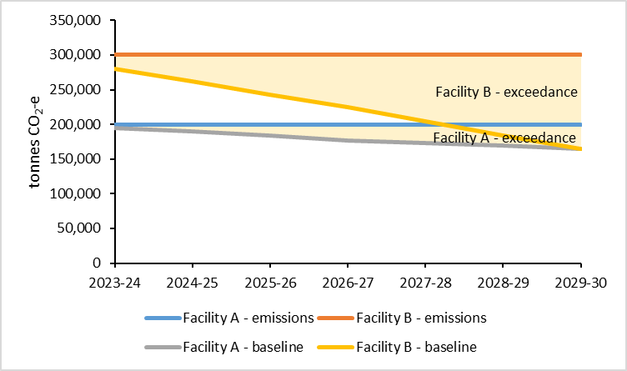

Exceedance at facility B has increased in each year, and facility A has an exceedance in each year. The total net exceedance represents the emissions constraint. Safeguard facilities can meet this constraint by:

* reducing emissions—which reduces exceedances at facilities A and B and could result in the generation of SMCs if either facility reduces its emissions below its baseline.
* buying SMCs—from other Safeguard Mechanism facilities with emissions below their baseline
* buying domestic carbon offsets—from project‑based emissions reductions projects which reduce emissions outside the scheme.

## *Underlying calculations*

**Table A1: Calculation for facility A**

|  |  |  |  |  |  |  |  |  |
| --- | --- | --- | --- | --- | --- | --- | --- | --- |
|  |  | 2023-24 | 2024-25 | 2025-26 | 2026-27 | 2027-28 | 2028-29 | 2029-30 |
| A | Emissions | 200,000 | 200,000 | 200,000 | 200,000 | 200,000 | 200,000 | 200,000 |
| B | Production | 250,000 | 250,000 | 250,000 | 250,000 | 250,000 | 250,000 | 250,000 |
| C | EI hybrid | 0.82 | 0.84 | 0.86 | 0.88 | 0.92 | 0.96 | 1.00 |
| D | Baseline no decline (B x C) | 205,000 | 210,000 | 215,000 | 220,000 | 230,000 | 240,000 | 250,000 |
| E | Decline factor | 0.95 | 0.90 | 0.85 | 0.80 | 0.76 | 0.71 | 0.66 |
| F | Baseline with decline (D x E) | 194,955 | 189,420 | 183,395 | 176,880 | 173,650 | 169,440 | 164,250 |

**Table A2: Calculation for facility B**

|  |  |  |  |  |  |  |  |  |
| --- | --- | --- | --- | --- | --- | --- | --- | --- |
|  |  | 2023-24 | 2024-25 | 2025-26 | 2026-27 | 2027-28 | 2028-29 | 2029-30 |
| A | Emissions | 300,000 | 300,000 | 300,000 | 300,000 | 300,000 | 300,000 | 300,000 |
| B | Production | 250,000 | 250,000 | 250,000 | 250,000 | 250,000 | 250,000 | 250,000 |
| C | EI hybrid | 1.18 | 1.16 | 1.14 | 1.12 | 1.08 | 1.04 | 1.00 |
| D | Baseline no decline (B x C) | 295,000 | 290,000 | 285,000 | 280,000 | 270,000 | 260,000 | 250,000 |
| E | Decline factor | 0.95 | 0.90 | 0.85 | 0.80 | 0.76 | 0.71 | 0.66 |
| F | Baseline with decline (D x E) | 280,545 | 261,580 | 243,105 | 225,120 | 203,850 | 183,560 | 164,250 |

## **More information**

Learn more about the Safeguard Mechanism reforms at [**https://consult.industry.gov.au/safeguard-mechanism-reform-consultation-paper**](https://consult.industry.gov.au/safeguard-mechanism-reform-consultation-paper)**.**